**Analytic Memo 3**

**Jessica Lewis, 9/24 - 9/28**

1. **What data did you collect this week?**

Tuesday 9/25

* Quiz #3
* Discussion #2
* Gave students a problem to solve and asked them to explain their answer on the blog. If they couldn’t get the answer, use the blog to ask for help from a peer.
* I completed the **Teacher Observation Form** for each student.

Friday 9/28

* Discussed the difference between explaining vs justifying.
* Modeled an example of an explanation and a justification.
* Challenged the students not to talk during the discussion (“pretend like you are at home and cannot communicate with your friends in person”).
* I completed the **Teacher Observation Form** for each student.
* Since Discussion #2 & #3 is over, I also filled out the **Blog Evaluation Rubric** for each student.

1. **Review the qualitative data that you collected this week. List five to ten words (potential codes) that come to mind as a result of this data.**

As I am starting to collect more and more data, I am seeing some of the same codes pop up during student observations. I have organized them into 3 different categories. The coding map that I had in my last memo will help to show connections between these codes. These are the codes I am using to help me identify patterns and themes during observation. I find this more organized and simpler for me to understand.

|  |  |  |
| --- | --- | --- |
| Peer Audience | Mathematical Discourse | Motivation |
| verbal peer collaboration  conscious of peer audience  intimidated by peer audience  strong self-efficacy/confidence  low self-efficacy  multiple perspectives | low literacy skills  strong literacy skills  teacher clarification  not understanding the question | off task  excitement  quiet  teacher redirection  lack of effort  highly egaged/focused |

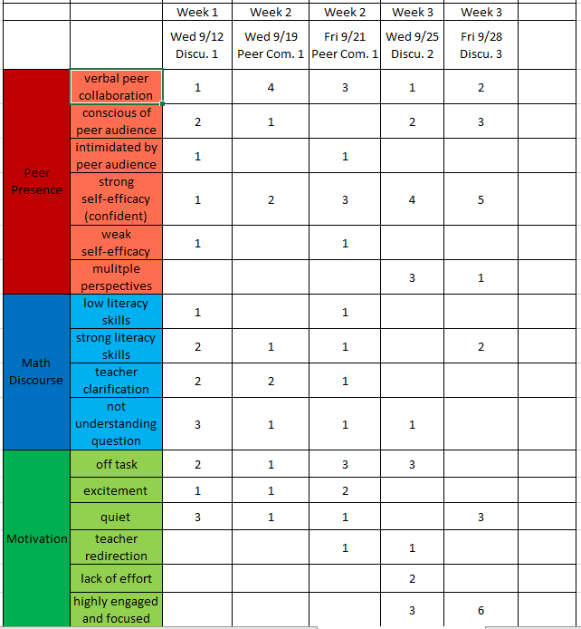I started a frequency chart to help me identify and compare week-by-week trends.

I am using a different set of codes for qualitative data to identify trends in academic achievement. I also changed my **Blog Evaluation Form** to better align and represent reoccurring codes. Here are the codes used for qualitative data:

|  |
| --- |
| Explanation |
| Justification |
| Peer Comments |
| Mathematical Discourse |
| Grammar & Punctuation |

1. **In a table, share the quantitative data that you collected this week. This data should not be individual according to student – but should be presented in the form of averages or percentages. Write a short explanation (one or two sentences) of what you think this data means in terms of your research question (s).**

**Teacher Observation Form -** The numbers below represent the average for 10 students

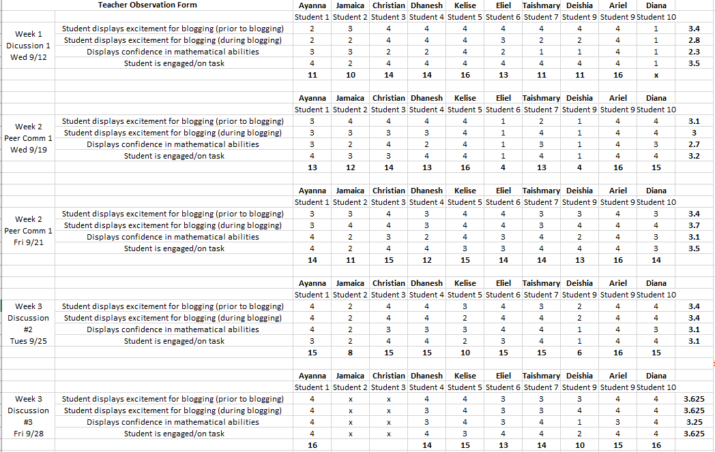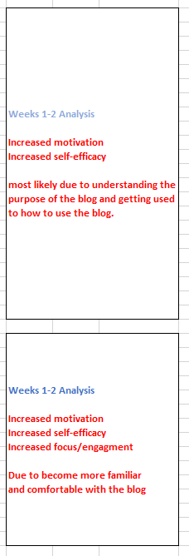

As the study progresses, the students are becoming more comfortable using the blog. Students understand how to access the blog and understand the purpose of writing on a blog. They are displaying more excitement before and during blog use and require less teacher direction each time we have a blog session. This is displayed in their confidence in mathematical abilities and engagement on the task. This instrument is strictly used for observations. Although a student may look confident in their mathematical abilities, this does not directly reflect their mathematical discourse and understanding of the content (this data is displayed in the **Blog Evaluation Rubric**).

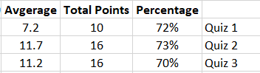**Quiz Scores (1,2,3) -** The numbers below represent the average for 10 students

The quiz scores are still stagnant. The students will have their first unit test this week. 4 questions on the unit test ask the students to explain their thinking. This will add dept to their assessment of explanation and justification skills.

1. **Write at least one paragraph (it could be more if you like) reflecting on your experience of the week in terms of both student performance and your own practice.**

This week the students became more comfortable with the use of the blog. They required less teacher assistance and were more focused and engaged on the task. When teacher assistance was requested, it was mostly for spelling and grammar clarifications. This supports the idea that students are consciences of their peer audience and want their writing to appear strong because they know their peers will be reading it (Clayton & Pringle, 2013).

Many students displayed excitement during the second blog sessions this week. They were exited and eager to share their explanation and justifications after they were presented with the problem. Most students were confident in their mathematical abilities since no one asked for teacher clarification on how to do the problem. Students who did not know how to solve the problem used peer communication on the blog for assistance.

Students enjoyed the challenge of only communicating with their peers on the computer. They were actively engaged and focused on the blog activity the for the whole duration of the session. Providing them with a task that challenged them to achieve a common goal (Kuo et. al, 2017) supported their peer engagement and increased their motivation and excitement for math.

1. **Write a few sentences (it could be more if you like) outlining the way that this week’s memo is different from last week’s memo.**

This week I changed the **Blog Evaluation Rubric**. In week 3 of data collection, some of the same codes kept coming up. I decided to change the Rubric so that it better represented and aligned to these codes.

Now that I am half-way through data collection, I have gathered enough data to identify the skills the need to be further developed for students to be successful in explaining and justifying their thinking. I wanted to specifically pinpoint the students’ explanation vs justification skills, engagement in student discussion, and their mathematical discourse. This past week we discussed the difference between explaining and justifying their answer. I also modeled an example for them on the blog. My hope is that these skills will become stronger the more they participate on the blog.

This week I plan to have the students further justify their answers from last weeks discussion. Although they are accurately explaining their solutions, they still lack in justifying skills. I plan to do this by leaving a comment on each of their posts that pushes them to further explain and justify their original post.

**Field Notes**

**Week 3 (Tues, 9/25) – Discussion #2**

* Students too a quiz right before blogging which caused them to lack focus and motivation. Lack of motivation
* Many Students did use peer comments to help them solve the problem multiple perspectives, explanation skills
* S: to teacher - “can you help me do this?”
* T: “See if your peer comments can help you first” peer collaboration, multiple perspectives
* 15 min later – T: “did it help?”
* S: “Yes, I was able to solve it correctly using my peers’ explanations” peer collaboration, multiple perspectives
* Students are explaining their thoughts, but are not using their justification skills explanation skills vs justification skills
* Some students did not post their explanations (ran out of time)
* Not many students posted an explanation on the blog since I did not make it mandatory and they ran out of time so I decided not to do a **Blog Evaluation Form** for this discussion.
* Next time:
  + describe the steps for solving this problem
  + create a post that requires students to explain and justify their thinking
  + model how to explain and reason
  + teacher joins the discussion to facilitate

**Week 3 (Fri, 9/28) – Discussion #3**

* Had a group discussion about explaining vs justifying thoughts.
* Modeled an example of a comment that explains and justify their response.
* Students were excited and engaged in the blog – motivation
* Enjoyed the challenge of not being allowed to verbally communicate – peer collaboration
* Took it seriously and followed directions - motivation
* Student did not know how to solve the problem – afraid to post a questions because she did not want her peers to know, she waited until someone posted their description – low self-efficacy
* Next Time:
  + Teacher check to see if all answers on paper are correct
  + Teacher post some comments on the blog to have students expand on their justification skills
  + Have students read peer blog posts and make corrections

This week I changed the **Blog Evaluation Rubric**. In week 3 of data collection, some of the same codes kept coming up. I decided to change the Rubric so that it better represented and aligned to these codes. I wanted to specifically pinpoint the students’ explanation vs justification skills, engagement in student discussion, and their mathematical discourse.